Amazon SQS
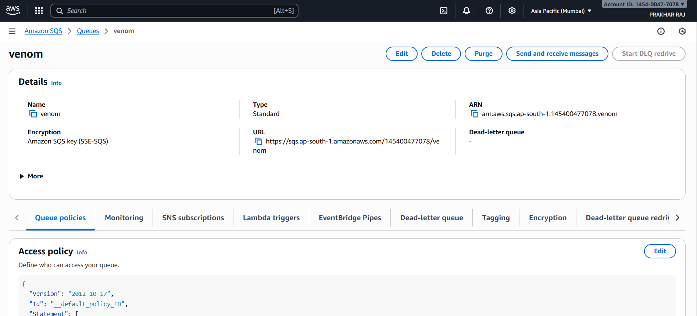
Amazon SQS Queue Summary: venom
General Details
- Queue Type: Standard
- Region: Asia Pacific (Mumbai)
- AWS Account ID: 1454-0047-7078
- Queue URL: https://sqs.ap-south-1.amazonaws.com/145400477078/venom
- ARN: arn:aws:sqs:ap-south-1:145400477078:venom
Security & Encryption
- Encryption Type: SSE-SQS (Amazon SQS managed key)
Dead-Letter Queue
- Associated DLQ: None
- Redrive Policy: Not configured
Access Policy
- Policy Version: 2012-10-17
- Policy ID: __default_policy_ID
- (Only partial JSON visible; full permissions not shown)
Management Options
- Available actions: Edit, Delete, Purge, Send/Receive messages
Configuration Tabs
- Queue Policies
- Monitoring
- SNS Subscriptions
- Lambda Triggers
- EventBridge Pipes
- Dead-letter Queue
- Tagging
- Encryption
- DLQ Redrive
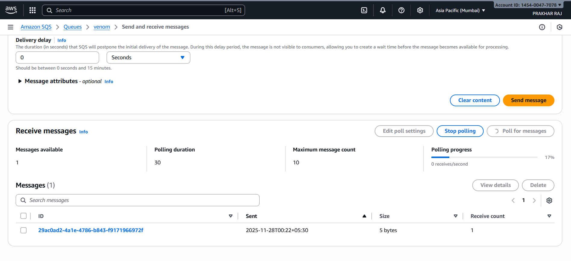
Amazon SQS Queue Summary: venom
General Details
- Queue Type: Standard
- Region: Asia Pacific (Mumbai)
- AWS Account ID: 1454-0047-7078
- Queue URL: https://sqs.ap-south-1.amazonaws.com/145400477078/venom
- ARN: arn:aws:sqs:ap-south-1:145400477078:venom
Security & Encryption
- Encryption Type: SSE-SQS (Amazon SQS managed key)
Dead-Letter Queue
- Associated DLQ: None
- Redrive Policy: Not configured
Access Policy
- Policy Version: 2012-10-17
- Policy ID: __default_policy_ID
- (Only partial JSON visible; full permissions not shown)
Management Options
- Available actions: Edit, Delete, Purge, Send/Receive messages
Configuration Tabs
- Queue Policies
- Monitoring
- SNS Subscriptions
- Lambda Triggers
- EventBridge Pipes
- Dead-letter Queue
- Tagging
- Encryption
- DLQ Redrive
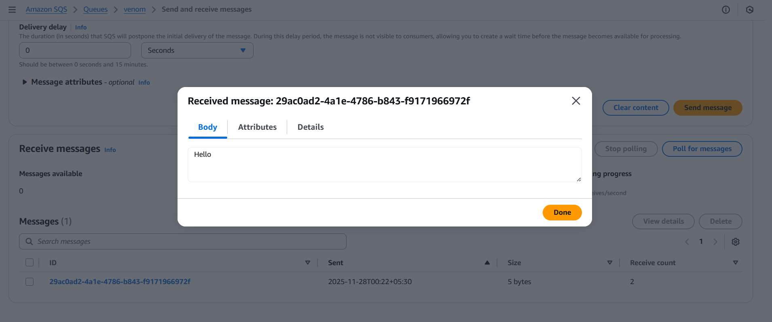
SQS Message Summary: venom Queue
Message Details
- Message ID: 29ac0ad2-4a1e-4786-b843-f9171966972f
- Body Content: "Hello"
- Size: 5 bytes
- Sent Timestamp: 2025-11-28T00:22+05:30
- Receive Count: 2
- Messages Available in Queue: 0
Interface Actions
- Options shown: Clear content, Send message, Stop polling, Poll for messages
- Tabs available: Message attributes, Message details

